GB Epic Fulffy



  Code Start Simulation Send To

## Basic

Search

. ... ..........



I

Diode Photoresis for Soil Mais ture

ONO  

Pi ezo



TEgIg Epic Fulffy





## -- rp q)g Simulator time: 00:00:03

All changes saved

Code Send To

Basic Search

-

Oiode Photoresistor Soil Moisture



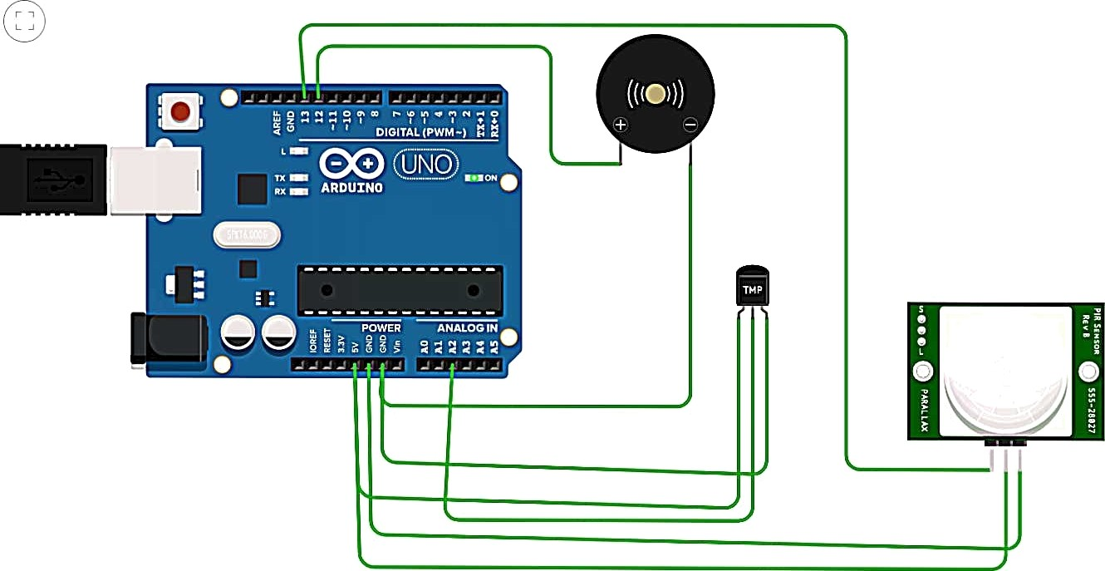DlMance...

Temperature MuTlimeter

Fex

GB Epic Fulffy



## Simulator time: 00:00:19 Code

Send To

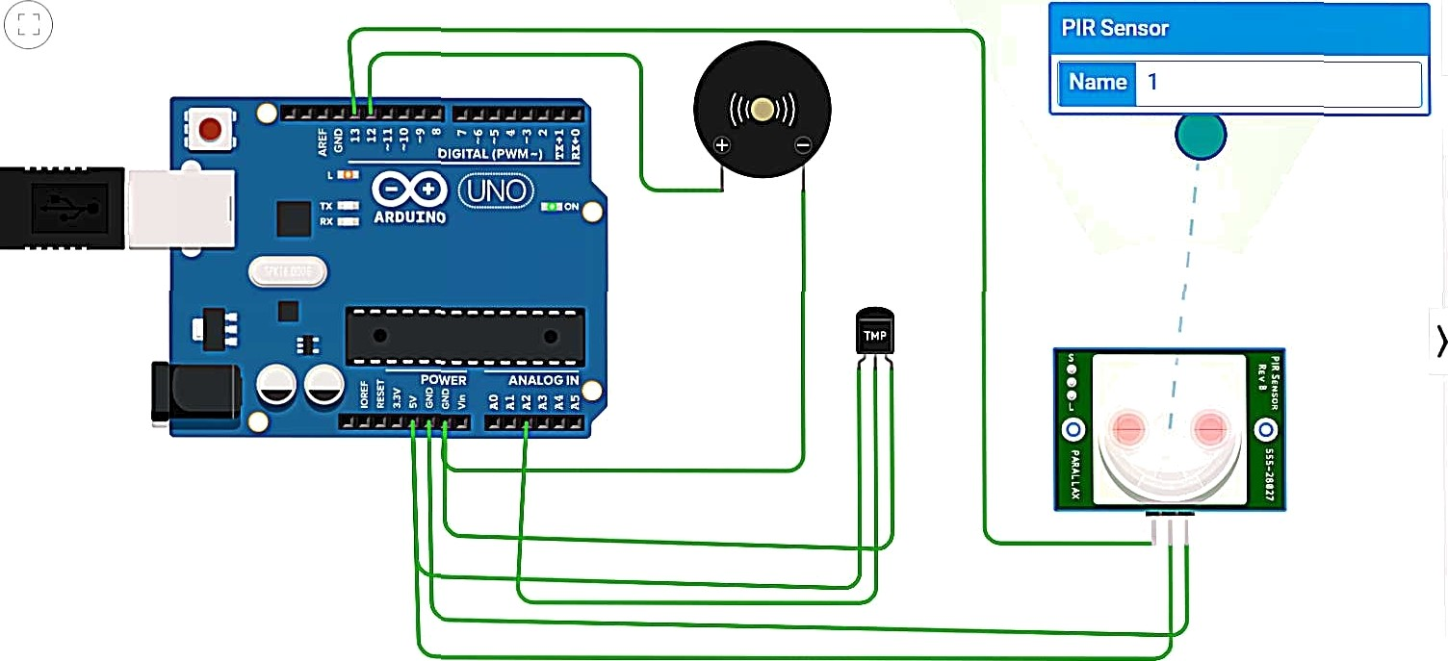Basic

## Search

.. +......... .

# 

0' de Photoresistor Soi M ture

ONO  

Piezo





Code Start Simulation Send To



# 



o o’ •



Text

1 voi d setu p() 2 (

1. Se rna T . begin(9688) ;
2. pSnMode( £ 3, INPUT) ;
3. pi nNode( 12, OUTPUT) ;

6 }

## ' * A " ] (AiduinoUuoR3)



*9* {

18 doubye data=ana1ogRead(A2) j 1:1 double n=data/1B24;

l£ doubie voit=n•5;

lz doubie off-voit-g.s;

* + l4 double 4•emperature-o-r--f*100;

18 rjt mot i on-d:igit a lRea d 13) g

t6 ton (int yreq-Aj*req‹=5; freq++)

i7 (

18 i-I{Temp e rarure i=6e )

19 {

2e Seriai.println(“Temperature is above 8g“);

tone (12, freq ) ;

Z2

23 )

de lay (188);

24 eds e

zs {

' Serial Monitor •

ZB . Epic Fulffy





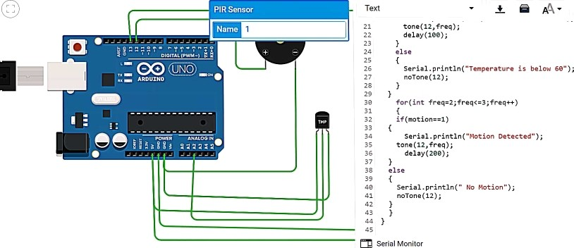 W   Ș Start Simulatïon Send To

II



1 (Arduino Uno R3)